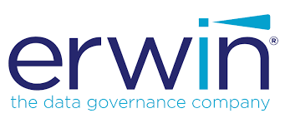

DataStage Reverse Smart Connector Design Document

Contents

**Supported Operating systems:** 3

**Supported Datastage versions:** 3

**Technology supported features:** 3

**Smart connector functionality:** 3

**Smart connector enhancement:** 3

**Customer Specific enhancement:** 3

**Talend context:** 4

**Code Walkthrough:** 4

## **Supported Operating systems:**

* Linux
* Windows

## **Supported Datastage versions:**

* Versions 7.x to Latest

## **Technology supported features:**

Technology: DataStage

* Jobs: Parallel, Server
* Shared Containers

## **Smart connector functionality****:**

* It creates mappings in Mapping Manager under the Job and Shared folder subject area.
* It also imports the SQLs embedded in the dataStage Job or Shared container.

## **Smart connector enhancement:**

* As per customer requirements we are going to update the enhancements.

## **Customer Specific enhancement:**

* The parameter replacement is happening in the below steps, parameters are being used in SQL queries.
* Teradata Componenet being used for TD DB, in case of other database need to use corrosponsing component.

**Talend**

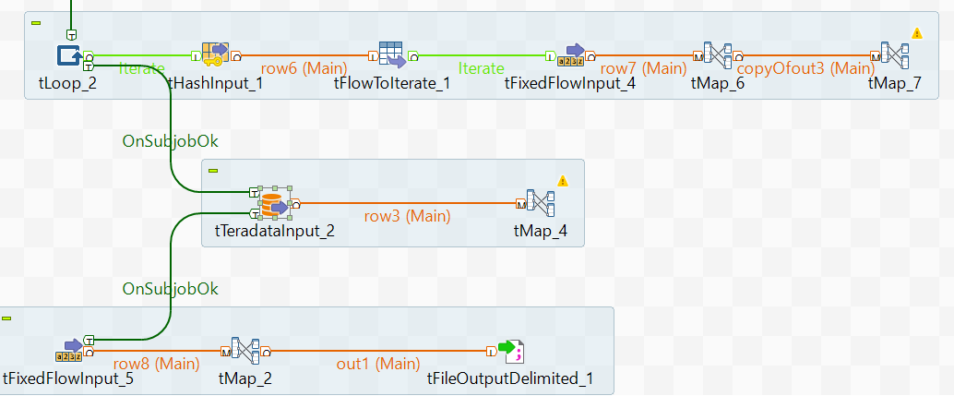

## **Talend context:**

* Mapping_Name
* SQL_Dir
* TD_HOST
* TD_DB
* TD_USERNAME
* TD_PASSWORD
* Temp_Dir_ws
* Txn_Name
* StageType
* System_Name
* ServerName
* assignServerName
* assignDBname
* Input_File
* LKP_DATATYPE_FILE
* SystemName
* projectId
* subjectId
* mappingId

## **Code Walkthrough:**

* **Extraction of Mapping Name.**

Below Screenshot from both XML and Talend showing how to fetch mapping name. In XML we are getting it from Property Name and In Talend we are getting this by passing context.

**XML**



**Talend**

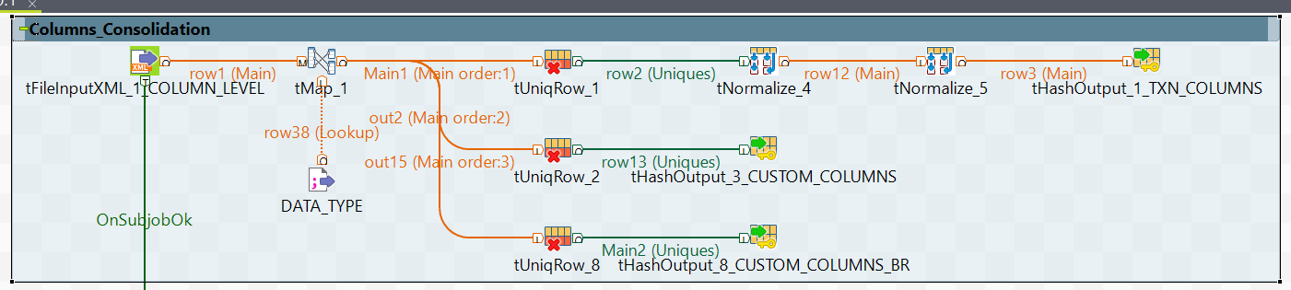

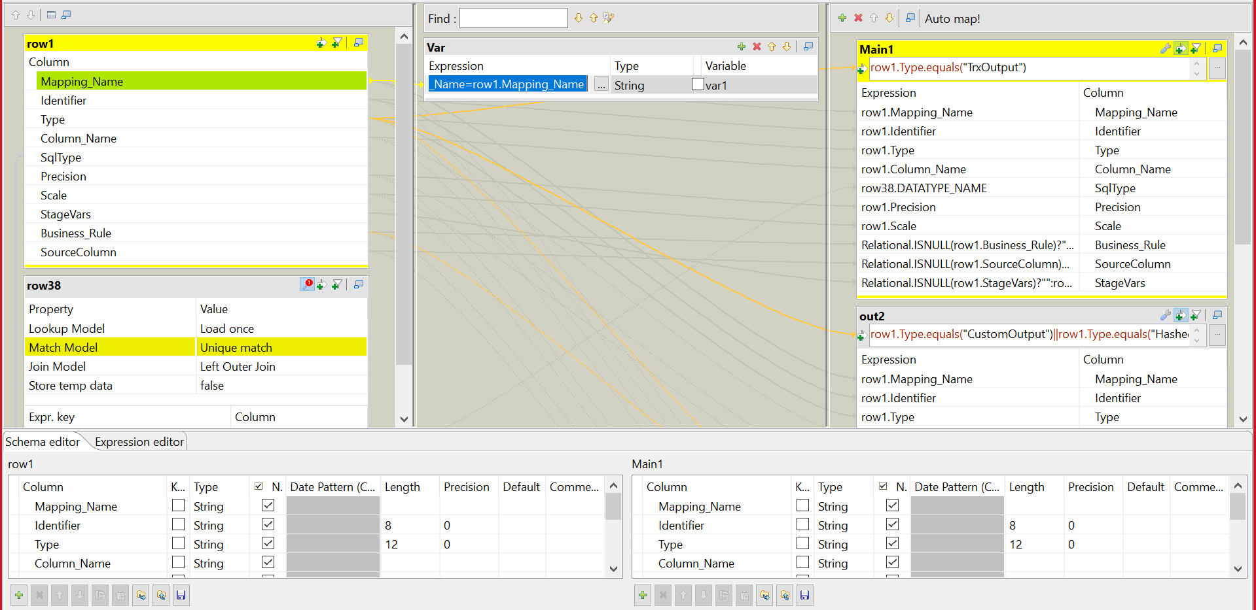

* **Identification of Component List.**

**XML**

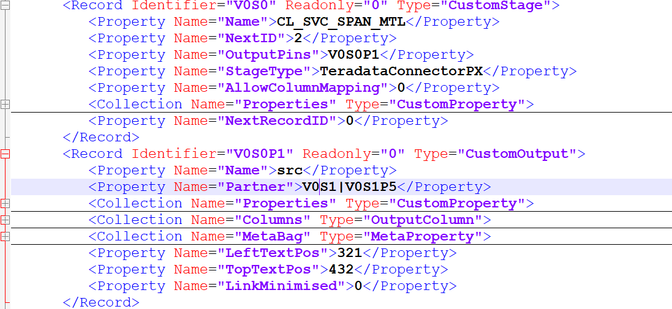

**Talend**

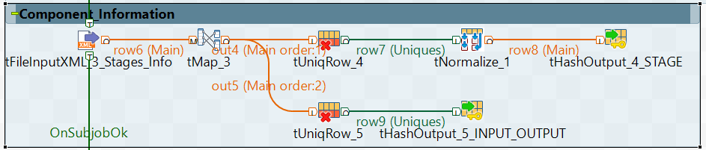

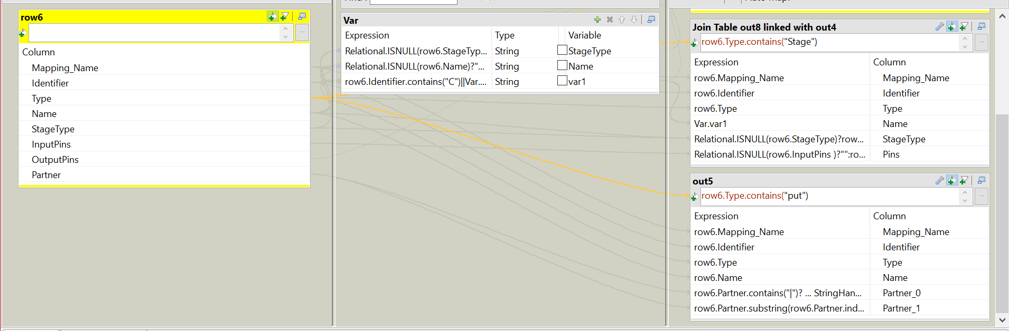

* **Preparation of the component Lineage.**

**XML**

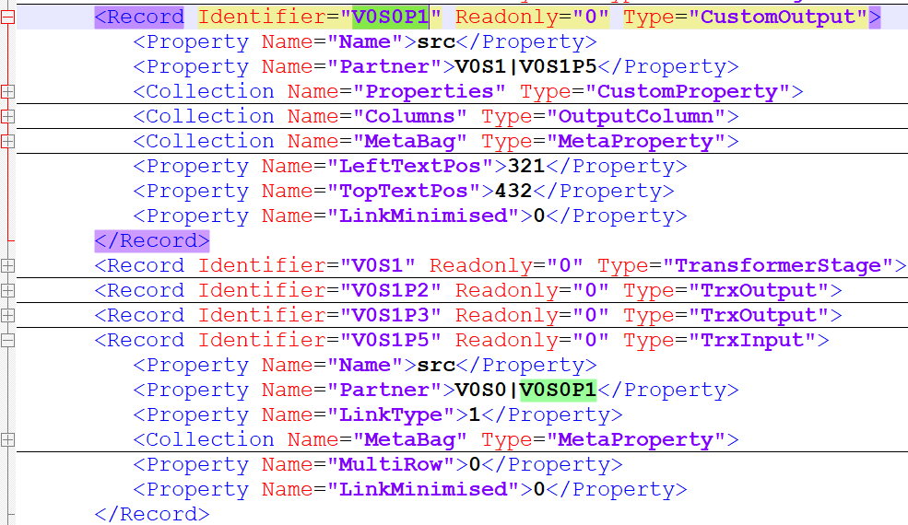

**Talend**

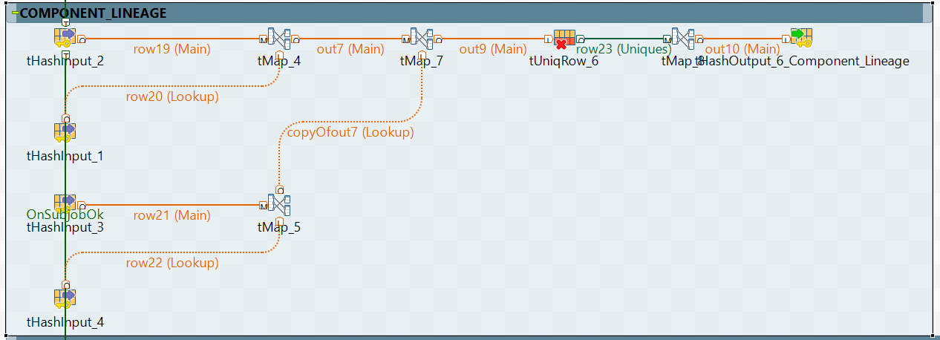

* **Extraction of component Level Column Information.**

**XML**

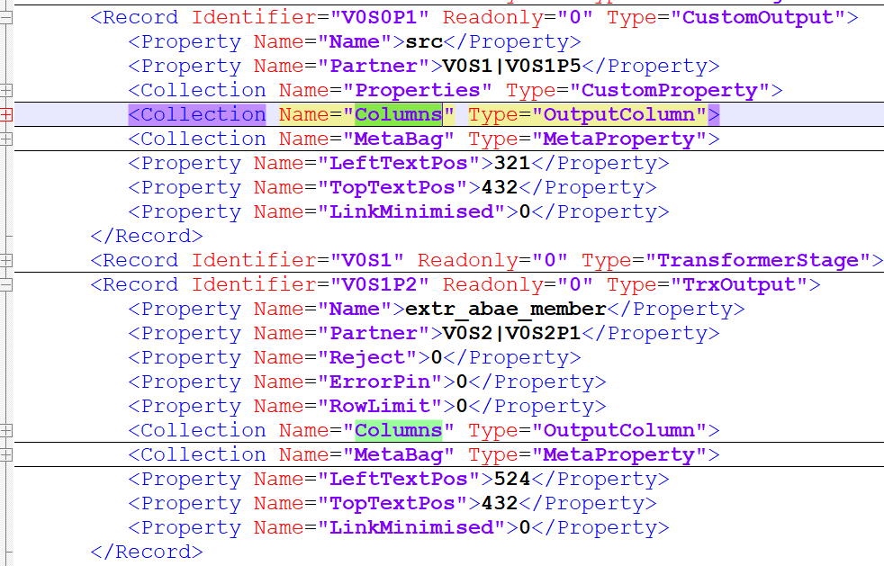

**Talend**

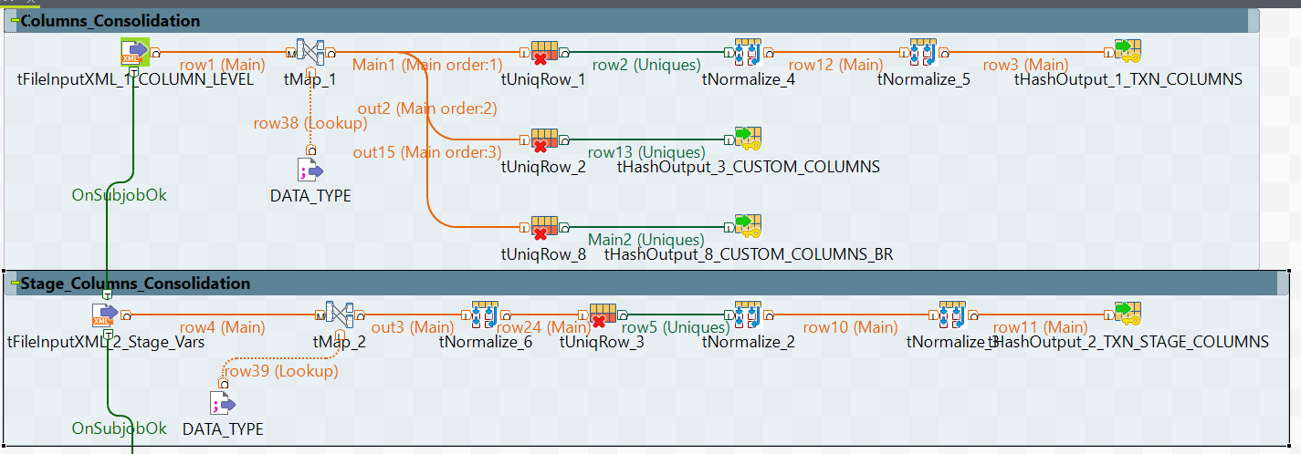

* **Column Lineage with components.**

**XML**

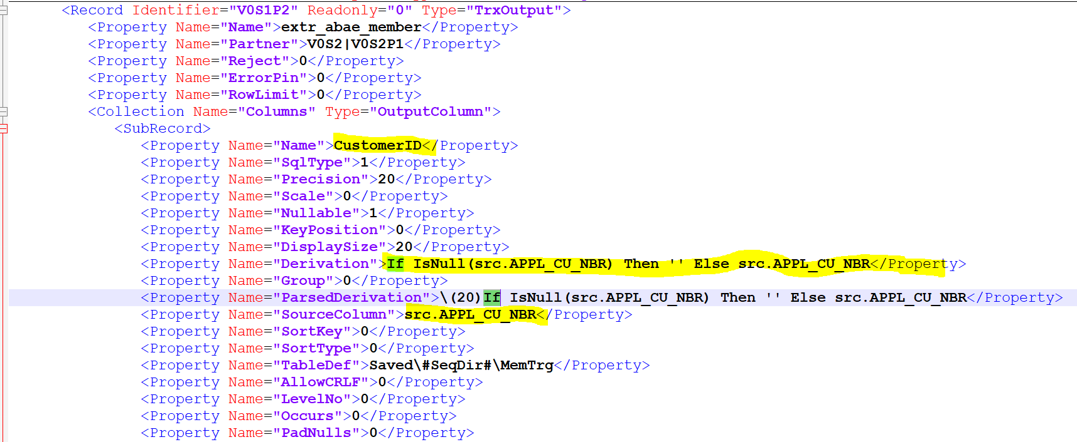

**Talend**

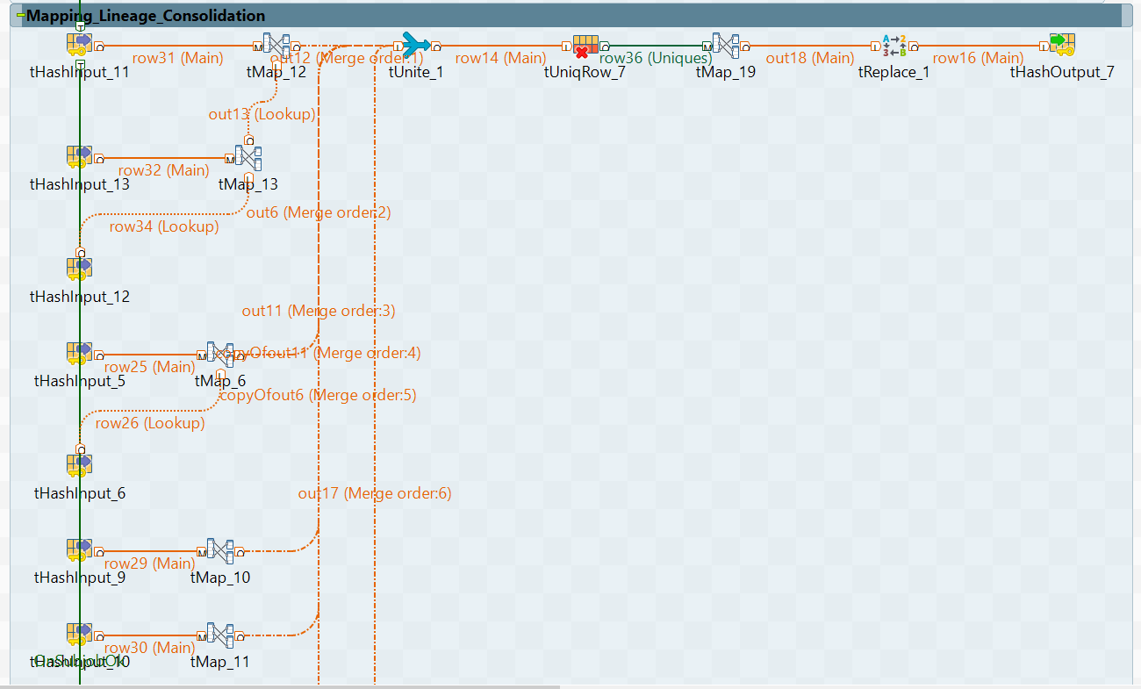

* **Validation of Business Rules in the Mapping Lineage.**

**XML**



**Talend**



* **Extraction of SQL Queries.**

**XML**

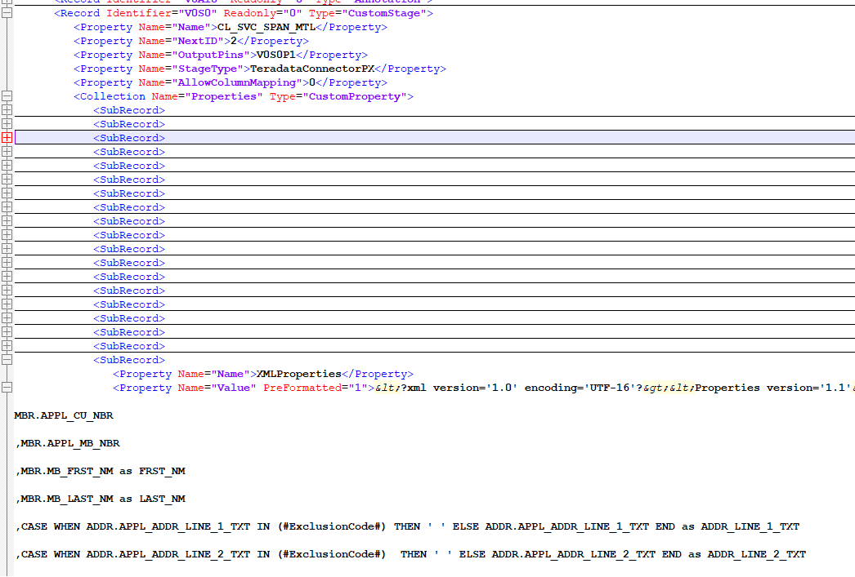

**Talend**

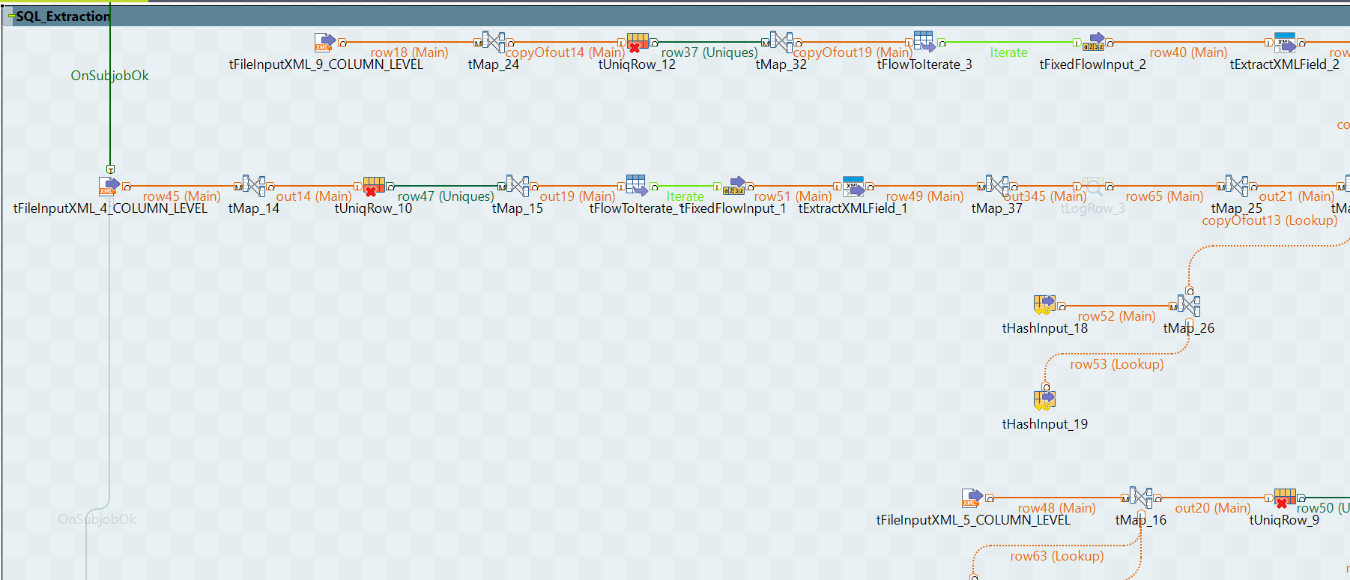

**SQL Snippet**

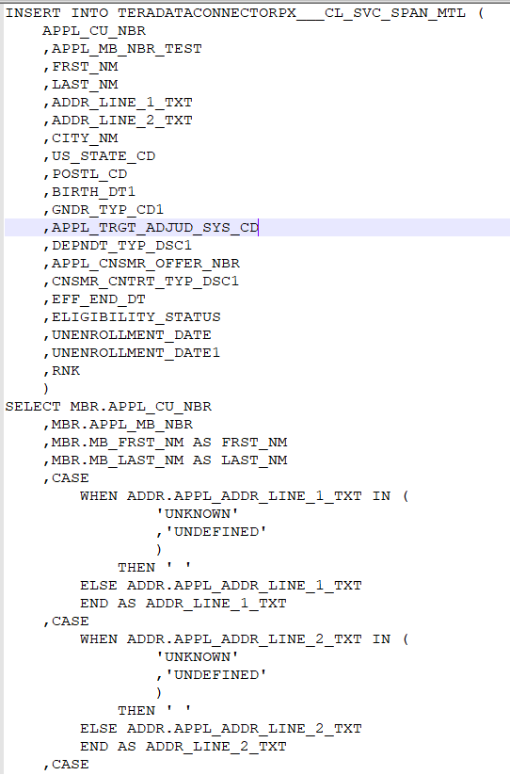

* **Validate the Incremental and Full Load for the Mapping Specficiation.**

**Incremental Load ( Talend & JSON )**



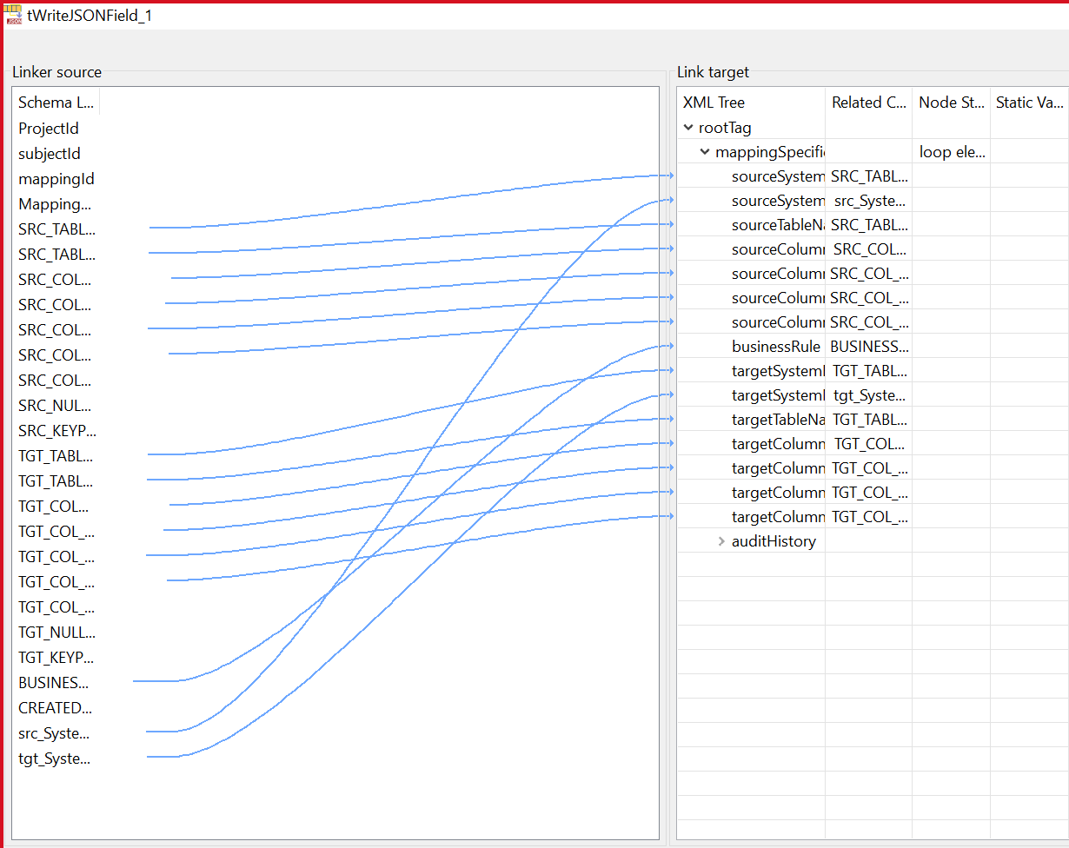

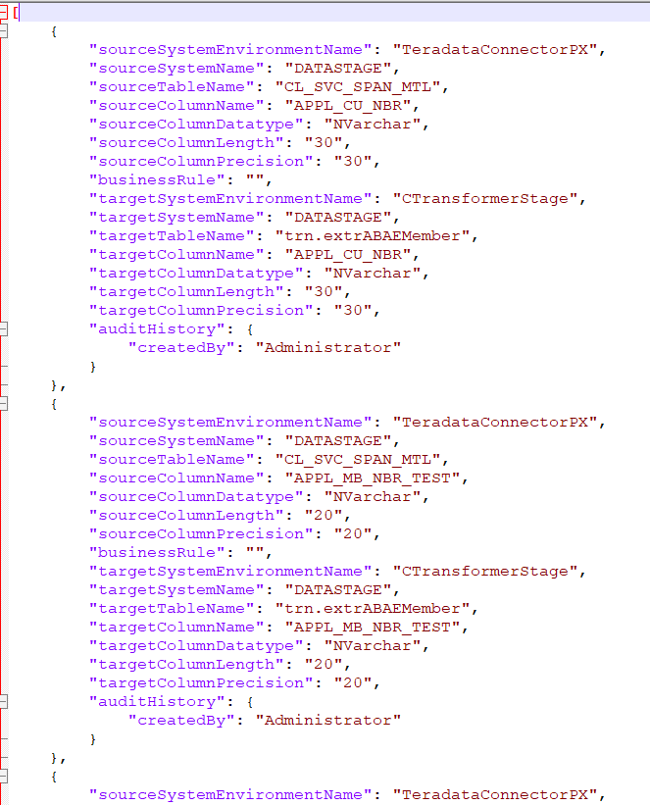

**Full Load ( Talend & JSON )**



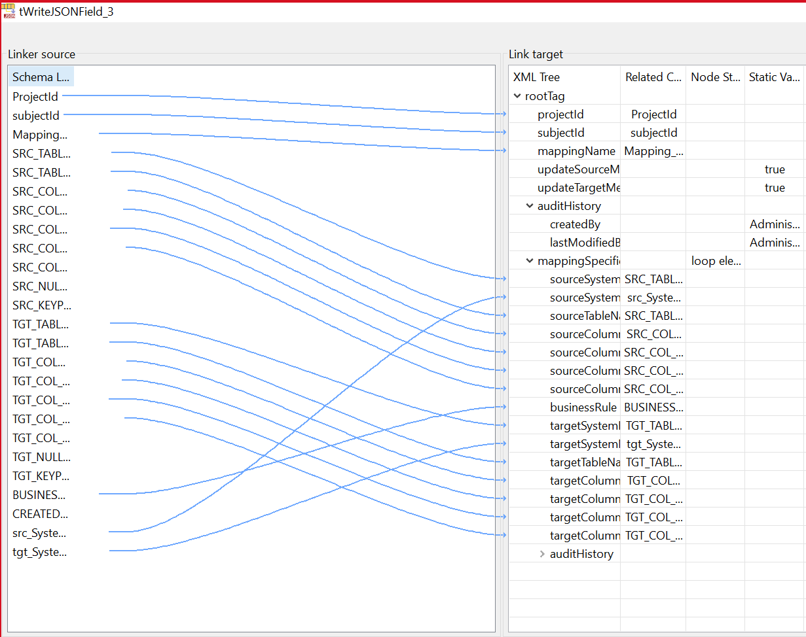

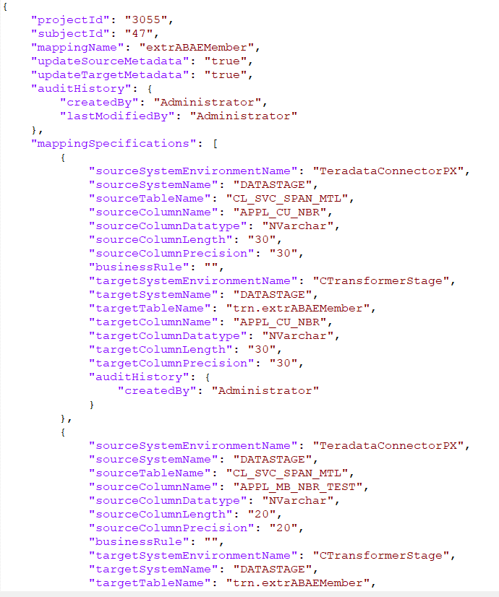

* Creation of Extended properties.

**Full Load ( XML & Talend )**

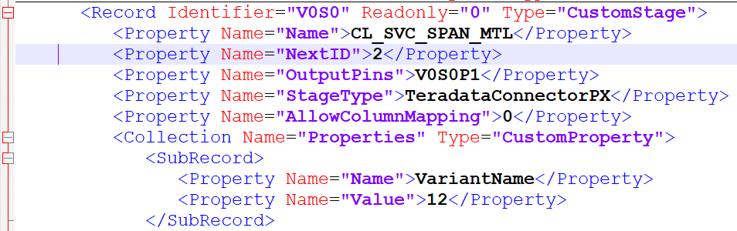

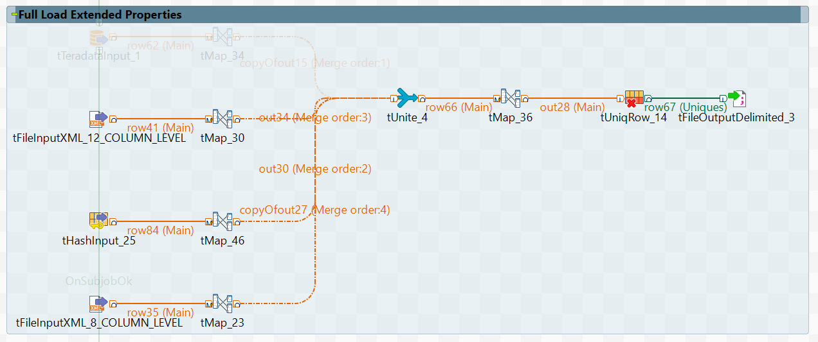

**Incremental Load ( XML & Talend )**



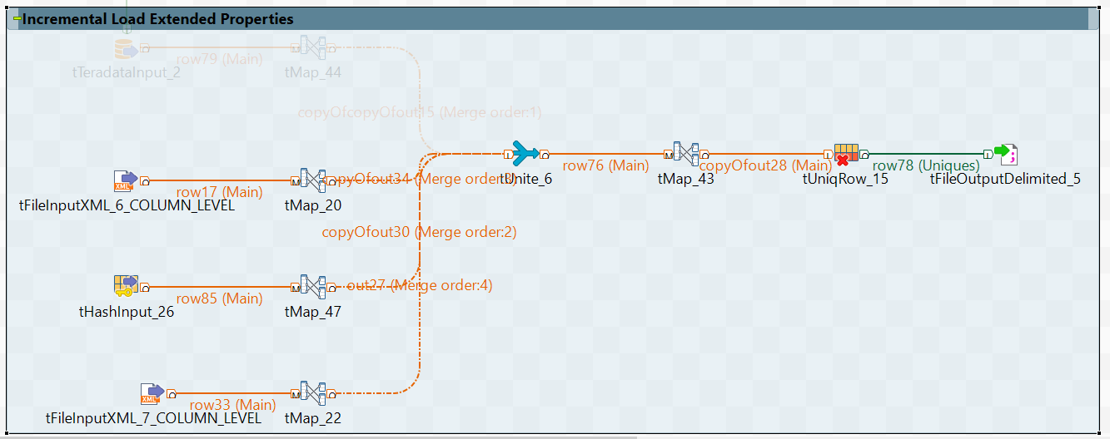

*Note* : *Please refer full Talend Job <HTML link> in the below Folder < DS_AMM_0.1.html >*

